SQL> CREATE VIEW MovieDetails as select title, d.name DirectorName, s.name StarName from movies m,directors d,stars s,moviesstars ms, moviesdirectors md where m.mid=ms.mid and d.did=md.did and s.sid=ms.sid and m.mid=md.mid;

View created.

SQL> SELECT * FROM MovieDetails;

TITLE DIRECTORNAME STARNAME
---------------------------------------- ------------------------------ ----------------------------------------
Inception Christopher Nolan Leonardo DiCaprio
Mayaanadhi Aashiq Abu Tovino Thomas
Oppam Priyadarshan Mohanlal
Avatar Christopher Nolan Zoe Saldana
Daddy Cool Aashiq Abu Mammootty
The Avengers Robert Zemeckis Robert Downey Jr.
Pulp Fiction Ridley Scott Leonardo DiCaprio
Master Lokesh Kanagaraj Vijay
Lucifer Prithviraj Sukumaran Mohanlal
Lucifer Prithviraj Sukumaran Prithviraj

10 rows selected.

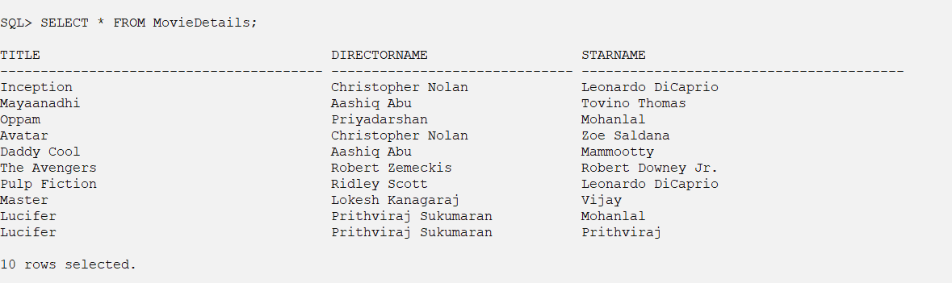

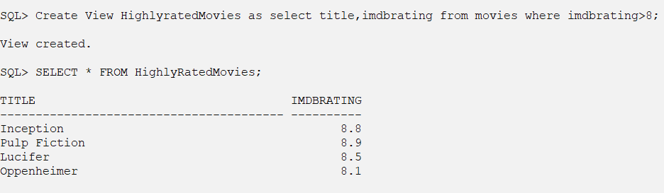
SQL> Create View DirectorMovies as select d.name Director,count(*) No_of_Movies from moviesdirectors md,directors d where d.did=md.did group by d.name;

View created.

SQL> select * from DirectorMovies;

DIRECTOR NO_OF_MOVIES
------------------------------ ------------
Prithviraj Sukumaran 1
Lokesh Kanagaraj 1
Martin Scorsese 1
Robert Zemeckis 1
Christopher Nolan 2
Aashiq Abu 2
Ridley Scott 1
Priyadarshan 1

8 rows selected.


